# Homework – Photo Album

After long and hard interviews with your employer you have finally got there! At the Quality Assurance Expert position in their biggest project for an international digital agency costumer. A web photo album! The stakeholders have shaken hands long time ago, but unfortunately as times go by, both sides got lost in translation.

The product owner’s specification is poor and unclear, but that’s not everything – as there weren’t anyone in between the management and the developers, the last ones have implemented the photo album very technically rather than user-friendly as well as they have introduced many bugs, because of the miscommunication and the lack of skilled testing engineer.

The costumer got very angry on the first project demo, thus they have rejected the offer to your employer. The last one decided to get back in game and recruit a very good professional in the quality assurance field in order to find all the misconceptions in the requirements and bugs introduced by the developers.

That’s how you’ve got there. You are given a web application which is a photo album, also a rough specification regarding the requirements. Your task is to find the misconceptions in the specification, the broken functionalities, user experience problems, security issues and do some automation for the repetitive work.

As you are the QA Expert in the project and the very first QA in the company, you can pick tools by your choice for test automation, test planning, test execution and bug reporting. But it’s very important to document all your work in corresponding issues in the issue tracker you have chosen and to give access to the issues tracker to your employer.

# Project Team

The Development lead is **Oliver Lines** (which explains presence of bugs), the lead of Design and Art is **Stevie Londar** and the Project Manager is **Stefan Hokinov**. Communicate well with them in the issue tracker and address issues to the relevant department.

# Software Requirements

1. Introduction
   1. Purpose

The purpose of this document is to present a detailed description of Web Photo Album application (hereinafter called Photo Album, Album or simply Project). It will explain some of the key features at very high level.

* 1. Scope

The document will cover the basic functionality on high level regarding the Photo Album. The user-management system, the album creation and operation and its respective details (hereinafter called Pictures). The administrative part – what the special user (hereinafter called Administrator or Admin) can and cannot do as well as the normal user.

1. Overall description
   1. System environment

The Photo album has three active actors and one cooperating system. All of them are accessing their parts from the internet. The Unregistered user can access the basic functionality of the project. One can view albums, categories and pictures. The Registered user can access some of the basic crud operations over the albums. One can create albums, edit its own albums, add and remove pictures from it, vote for albums and pictures, and comment albums and pictures. The Administrator can delete/edit any album or picture, can create, edit and delete categories.

* 1. Vocabulary
     1. **Album block** – An album block is information regarding an album structure. It consists of the Album Name in the very left side. The category it’s created in. Vote and Comment buttons. And a cover image on the very right side.

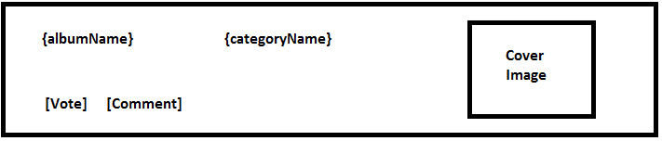

* + 1. **Picture view** – A picture view is information regarding a picture structure. It consists of the Picture name on the top (In format: Picture name: {pictureName}). The picture itself under it. The album name it’s added in (In format: Album: {albumName}). A description under it, if any. Information about the creation date and the author of the picture. Under it are placed comments, each on new line and Pictures rating which is the average rating for this particular picture. Under the rating are placed correctional buttons. Vote button and Comment button. If the user is logged and is administrator or picture owner two additional buttons are shown – Edit and Delete.

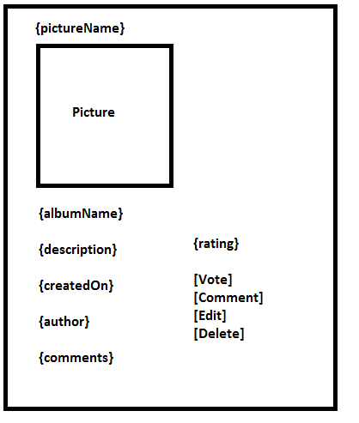

* + 1. Album view – An album view is information regarding particular album structure. In the header is placed its name and navigational buttons if the logged in user is administrator or album’s owner – Add Picture, Edit album, Delete Album. Under the header is placed the category where album is created in. It is a hyperlink leading to the particular category information. Under it, as a heading, is placed the description, then the albums author. Under them are listed all pictures in this album in a grid with 4 pictures per row paged by 12 per page. Each picture is a thumbnail and a hyperlink leading to the corresponding Picture view. Under the pictures there is information regarding the date created, comments, each on new line and the average rating for the album. Under the rating are navigational buttons Vote and Comment.

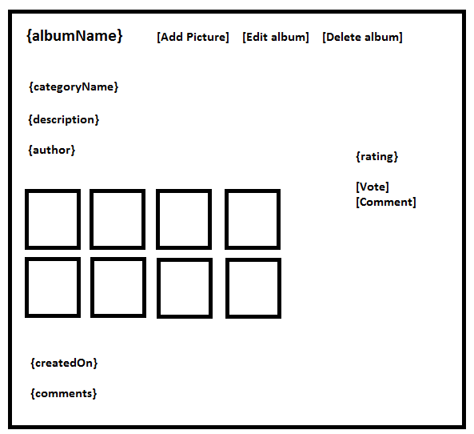

* 1. Functional requirement specification
     1. Use Case 1 (Accessing the system)

The system is accessed through the internet from its initial URL. It loads header, navigation bar and a home page

* + 1. Use Case 2 (Navigation bar)

The navigation bar has navigational hyperlinks to the home page, albums list, categories list and the search bar. As well as it should have navigation to the Album creation.

* + - * 1. Navigation bar – user management

When the visitor is unregistered, hyperlinks navigating to the Login and Register page should be present. When the visitor is registered or administrator a hyperlink navigating to the Logout page should be present instead. When user is successfully logged out, there should be a redirect to the home page.

* + 1. Use Case 3 (Home page)

The home page shows the three Album blocks ordered by highest rating and a header “Most highly ranked albums”. Clicking the Vote button on an album leads to the Album voting page. Clicking on the Comment button on an album leads to the Album comment page.

* + 1. Use Case 4 (Album Voting Page)

Information regarding the album name is shown and a rate box where user can place a vote between 1 and 10 inclusive. The respective information regarding the vote range is shown in the box. When clicking on “Vote” button, if the date is valid, the vote is counted for the respective album and for the average rating calculation. If the input date is invalid, a respective error box is shown.

* + 1. Use Case 5 (Album Comment Page)

Information regarding the album name is shown and a comment text box where user can place a comment for the particular album. We do not support text stylization, so there are no buttons for editing the text. The text cannot be empty. When clicking on “Comment” button, if the data is valid, the comment is placed and a redirect to the respective album is made. If the input data is not valid, a respective error box is shown.

* + 1. Use Case 6 (Add picture to album)

In order to add picture to album, one needs to be the album owner or the site administrator. By clicking “Add picture” from Album view, the user is navigated to a page and prompted for picture name, picture description and picture url, which must be a valid URL of a picture extension. Clicking on “Create picture” button validates all the fields. If everything is validated, the picture is added and the user is redirected back to the album. Otherwise a message is shown in the error box.

* + 1. Use Case 7 (Categories list)

Clicking on the Categories hyperlink from the header navigates to the categories list. For any normal user, a category name and the number of albums in it is shown. Each category is hyperlink, leading to category view, where all album blocks in that category are shown in descending order by their creation. If the user is administrator, buttons for adding, editing or deleting the category are present.

* + 1. Use Case 8 (Albums list)

Clicking on the Albums hyperlink from the header navigates to the albums list. Albums list is a collection of all album blocks in descending order by their creation in the Photo Album overall. There are 10 album blocks per page. Pages can be switched by clicking on particular page under the album blocks.

* + 1. Use Case 9 (Search)

Clicking on Search hyperlink from the header navigates to a page where a field for searching a keyword in category name, picture name or/and album name is present. If there are any categories/pictures/albums containing that keyword results are shown under the search box after clicking “Search” button. If there are no results, “No results found” message appears instead.

* + 1. Use Case 10 (Add Album)

Clicking on Add album hyperlink from the header, if the user is logged in, navigates to a form where user can enter unique album name, choose category name from a dropdown from the existent categories and write a certain description in the description textarea. If the user is not logged in, one is redirected to the login page. By clicking “Create album” button, if all data is valid, the album is created and the user is redirected to the new album page. If there is invalid data, an error box is shown instead.

# Tasks

1. Create enough test cases to test the functionalities described in the functional specification.
2. Save those test cases in simple files (TXT or XLS/X).
3. Set correct priority to your test cases depending on the functionality importance. Most important test cases that has to be run are the highest priority, the least important test cases are the lowest priority.

# Resources

There is only one administrator and you are not allowed to create more administrators. There is only one administrator whose username is “admin” and the password is “admin”.